**Name: Navjyot Sakhalkar**

**PRN No: 2019BTECS00011**

**Practical No 5 A:To design and develop web pages using HTML fundamental and formatting elements**

**Problem Statement 1:**

Design a static web page using HTML for Chemistry Department information. Access it locally and in LAN using web server.

**Github:**

[**Navjyot07/PL-3 (github.com)**](http://navjyot07/PL-3%20(github.com))

**Deployed at:** [**https://pl3-assg-5a.web.app/**](https://pl3-assg-5a.web.app/)

**HTML Code:**

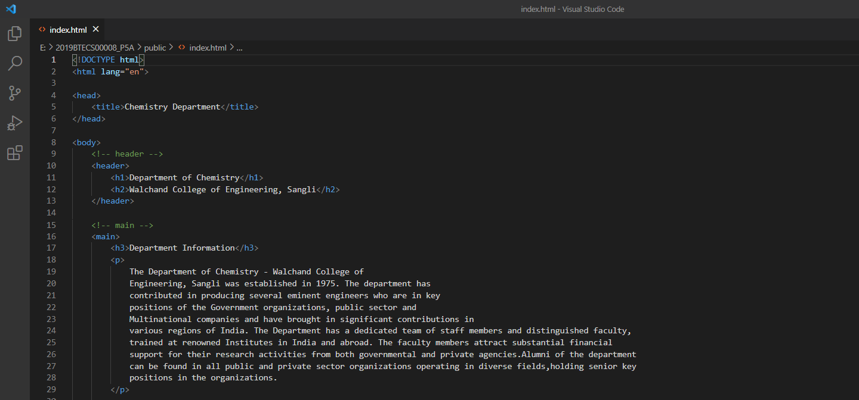

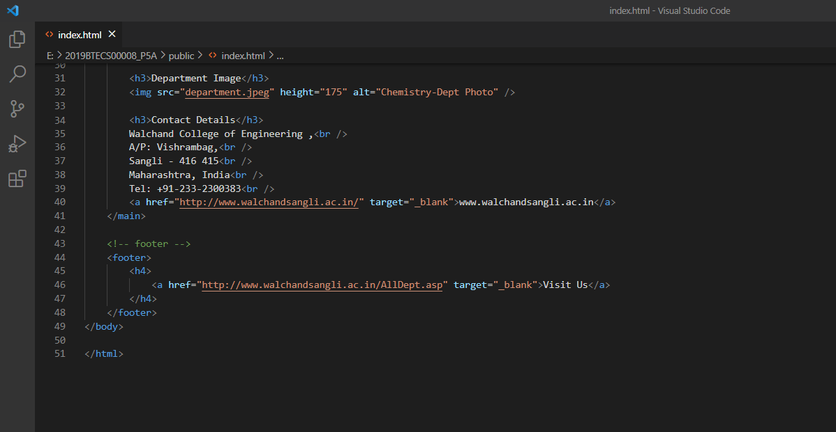

**Website:**

